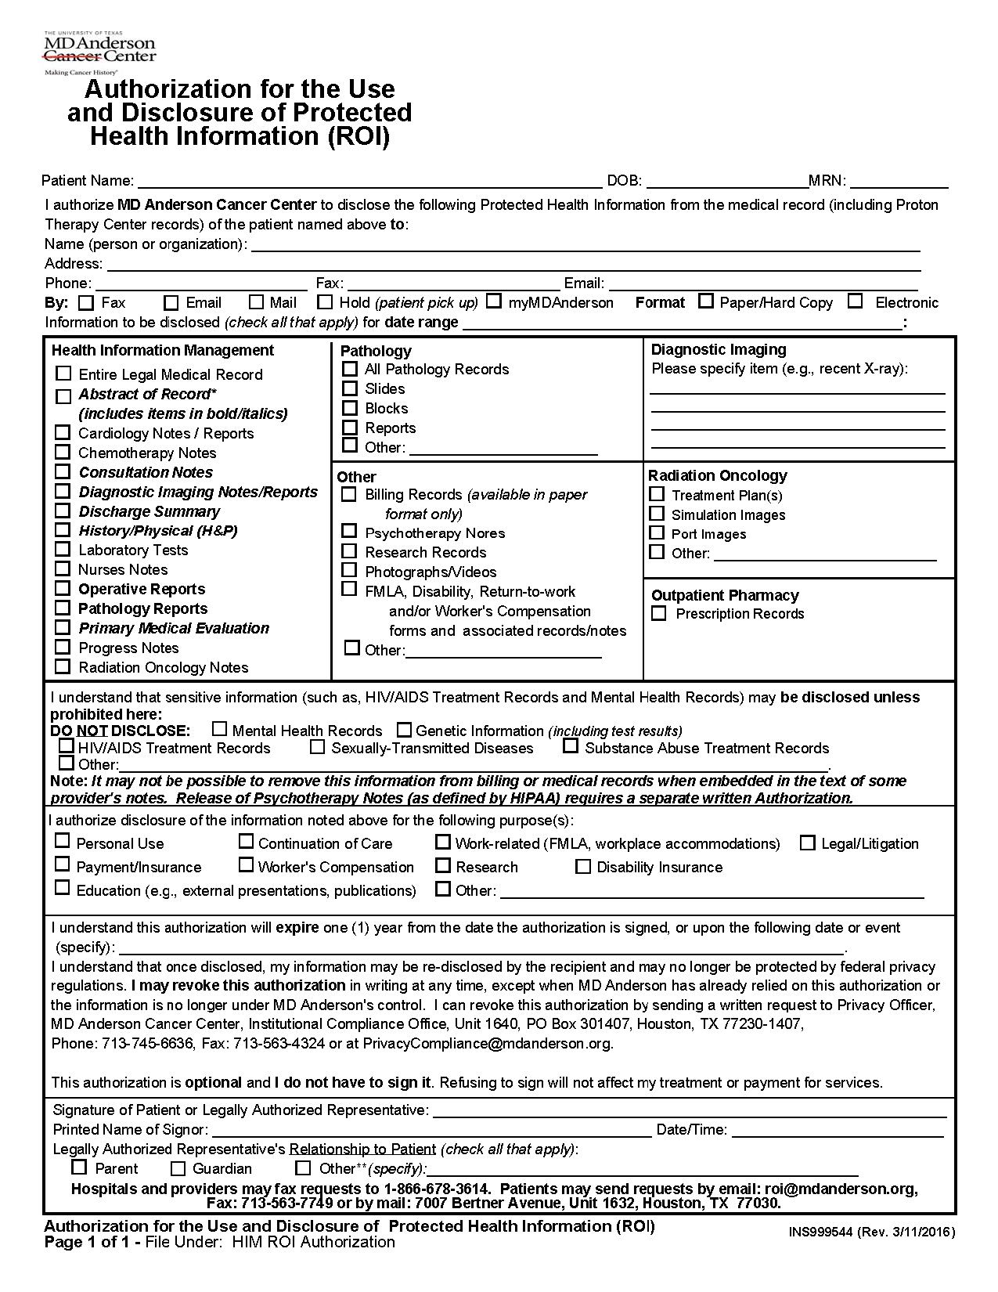
Batman
01/01/1979
Axiom Requisition Copy Service
2869 Jolly Road-Okemos, MI 48864
(877) 886-5090
(517) 886-4116
records@axiomcopy.com
✓

FROM 01/01/1979 TO PRESENT: Any and all MEDICAL RECORDS, including but not limited to patient history form(s), reports, etc. pertaining to Batman SSN: xxx-xx-5555, DOB: 01/01/1979.
✓

✓

✓

✓

End of Litigation

